Sulz am Neckar, June 2023

Positioning bushes with status sensor from KIPP:
All positions under control

HEINRICH KIPP WERK has expanded its portfolio with a new series of intelligent positioning and locating bushes with status sensor. These enable the integration of a central positioning control for indexing and ball lock pins in the production process. The bushes are available complete with integrated sensor or, as an alternative can be equipped by the user with commercially available inductive sensor types.

KIPP assists users in making their processes even more transparent and reliable with a new series of intelligent positioning and locating bushes. These bushes with integrated status sensor enable actuation-dependent process control. In addition, it can be ensured that the operating or engaging element is located at the desired spot, e.g. in the format adjustment of packaging machines or on assembly fixtures in classic machine constructions.

The bushes form a mounting point for indexing and ball lock pins, in which they can be securely and accurately located. In the standard version, an inductive sensor is installed in the positioning and locating bushes, which can be adjusted via a locknut. This enables electronic feedback as to whether a pin is located in the bush or not. When using several bushes, it can be determined in which one an operating or indexing element is located.

The sensors have a two metre long, three-core PVC cable that transmits the signals processed by the sensor to the machine control. This permits the user to control the position of the pin from a central position. This is particularly important for process-relevant workflows. For example, the control of the individual work steps can be used to specify that a machining cycle only begins when all the pins are in the correct position.

The new series includes steel or stainless steel positioning bushes, stainless steel locating bushes and stainless steel locating bushes for ball lock pins with twist knobs. Each variant is available either complete with a status sensor or as a version where the customer installs a sensor themselves. The latter has a locknut for mounting a commercially available inductive sensor with a diameter of 3 mm.

(Characters including spaces: 2,139)

Image overview:

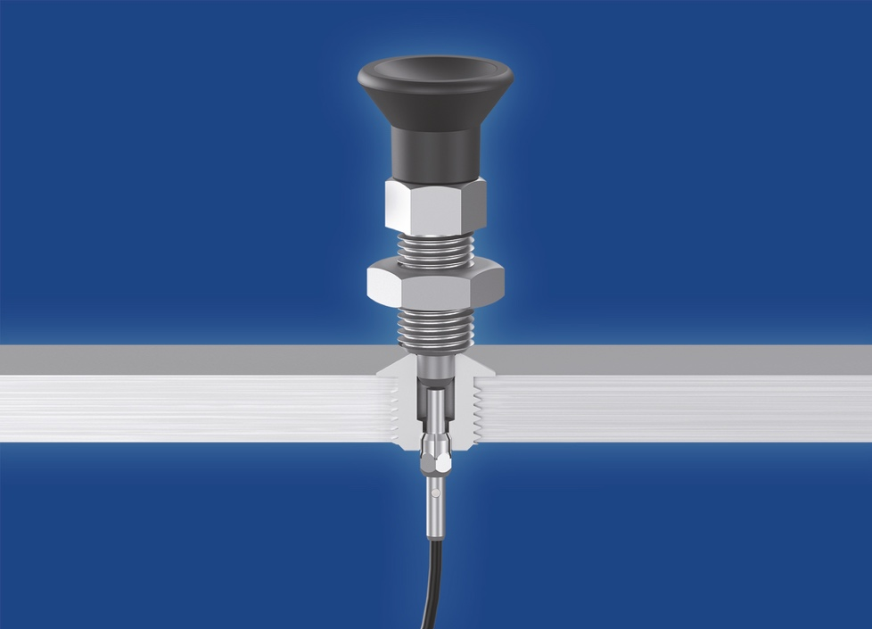
KIPP_Buchse mit Zustandssensor_1.jpg
The new positioning and locating bushes with status sensor from KIPP ensure that the operating or engaging element is always in the desired position. The signals processed by the sensor are transmitted to the machine control via a three-core PVC cable. Image: KIPP

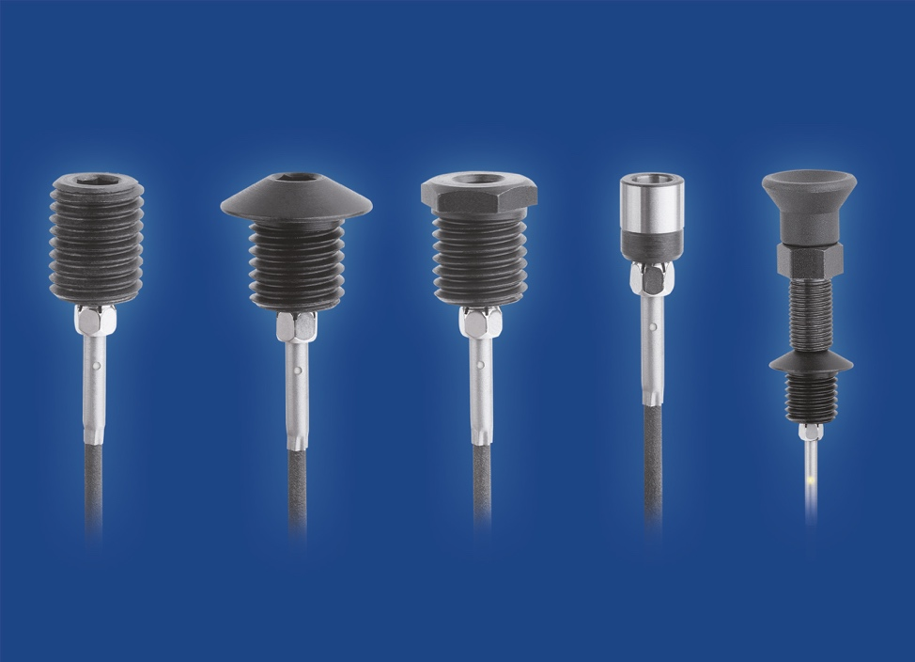
KIPP_Buchse mit Zustandssensor_2.jpg
The positioning bushes with status sensor are available in steel or stainless steel - with full-length thread, thread with approach taper, thread and collar or as a smooth design (from left to right). The illustration far right shows an application example. Image: KIPP

Deeplinks:

https://www.kippwerk.de/de/en/News/KIPP-News/Positioning-bushes-with-status-sensor.html

https://www.kippwerk.de/de/en/Products/Operating-parts-standard-elements/Spring-plungers-indexing-plungers-ball-lock-pins/Indexing-plunger/Positioning-bushes-steel-or-stainless-steel-with-status-sensor.html

Additional information and press photos
See www.kipp.com, Region: Germany, Category: News / Press section

Meta-Title: Positioning and locating bushes with status sensor from KIPP

Meta-Description: The intelligent bushes permit central positioning control of indexing and ball lock pins in the production process.

Keywords: KIPP, HEINRICH KIPP WERK, positioning bushes with status sensor, positioning bushes, bushes, locating bushes, inductive sensor, ball lock pin, indexing plunger, format adjustment, packaging industry, fixture construction

Download Area:
https://www.kipp.com/gb/en/Download/Press-area.html

HEINRICH KIPP WERK GmbH & Co. KG
Andre Jerke, Marketing
Heubergstrasse 2
72172 Sulz am Neckar, Germany

Telephone: +49 7454 793-7644
Email: andre.jerke@kipp.com

Press office:
Köhler + Partner GmbH
Brauerstrasse 42 • 21244 Buchholz i.d.N.
Telephone +49 (0) 4181 92892-0 • Fax +49 (0) 4181 92892-55
info@koehler-partner.de • www.koehler-partner.de

