Sulz am Neckar, October 2022

Robust, light, ergonomic:
New clamping levers with all-plastic grips from KIPP

Very high rigidity and strength with low weight: Thanks to these properties, the new clamping levers with all-plastic grips are ideal for mobile applications such as in the rehabilitation sector. HEINRICH KIPP WERK continues a tradition regarding the design. These ergonomic products impress with their modern appearance and pleasant haptics.

The grips of the clamping levers are made from a special high-performance plastic. Specifically, it is a fibreglass reinforced thermoplastic. This material permits the toothing to be incorporated directly into the grip element. The zinc die-cast toothed ring can thus be dispensed with as an encapsulated insert in the plastic grip.

As with clamping levers made of other materials, these new products facilitate the clamping or fixation of workpieces and other objects. Users benefit from tool-free installation and rapid adjustment. In addition to the classic areas of application in machine and fixture construction, clamping levers are also used for simple height adjustment of telescopic stands or for positioning in measuring technology. In the rehabilitation sector, they enable the easy adjustment of footrests on wheelchairs or the handle height on mobility frames.

Clamping levers are available with a variety of thread diameters (M4-M16) with female and male threads and in five different grip sizes, depending on the application. The inserts are available as black oxidised or blue passivated steel as well as a stainless steel version.

The grip element made of high-performance plastic is available in seven standard colours. On request, KIPP can also produce the clamping levers as models made of high-temperature plastic - these clamping levers are designed for permanent operating temperatures of up to 160 °C.

(Characters including spaces: 1,798)

Image overview:

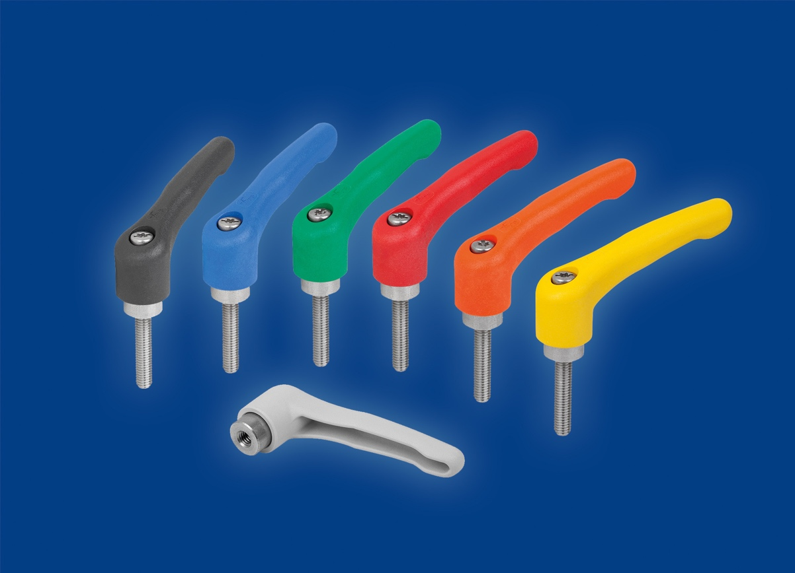
The new clamping levers from KIPP with all-plastic grip are ideal for all classic and mobile areas of applications.

Other information and press photo's
See www.kipp.com, Region: Germany, Rubric: News/Press section

Meta-Title: Robust and light plastic clamping levers
Meta-Description: The new clamping levers from KIPP with all-plastic grip are ideal for all classic and mobile areas of applications.

Keywords: KIPP, HEINRICH KIPP WERK, clamping lever, all-plastic grip, rehabilitation sector, mobile applications

Download-Area:
https://www.kippwerk.de/de/en/Download/Press-area.html

HEINRICH KIPP WERK GmbH & Co. KG
Stefanie Beck, Marketing
Heubergstrasse 2
72172 Sulz am Neckar

Telephone: +49 (0)7454 793-30
E-mail: stefanie.beck@kipp.com

Press office:
Köhler + Partner GmbH
Brauerstrasse 42 • 21244 Buchholz i.d.N.
Telephone +49 (0) 4181 92892-0 • Fax +49 (0) 4181 92892-55
info@koehler-partner.de • www.koehler-partner.de

