Press release Sulz am Neckar, Germany, September 2019

More room for the future:
HEINRICH KIPP WERK expands apprentice workshop

Finding qualified and motivated apprentices is one of the key tasks in medium-sized businesses. After all, the recruitment of educated young women and men is an essential part of the company's internal recruiting concept. Those responsible at HEINRICH KIPP WERK are aware of the importance of searching for apprentices and have been investing in their services for years. The latest change is an expanded apprentice workshop.

46 young people are currently doing apprenticeships at HEINRICH KIPP WERK, 26 of them in the commercial sector. In a few years they will be able to call themselves industrial mechanics, tool makers, process mechanics, mechatronics engineers or machining technicians. "We want to give our apprentices the best conditions for a successful apprenticeship. We invest in young talent – and therefore also of course in our own future," says Managing Director Nicolas Kipp.
With 320 m², the area of the apprentice workshop is now twice as large as before. "In our apprentice workshop, our apprentice learn their trade on professional turning, milling and eroding machines. We have recently expanded our stock with three CNC machines. The apprentice workshop now has a total of six CNC machines and 10 conventional machines," explains Daniel Hütter. The long-standing trainer at HEINRICH KIPP WERK and his new colleague Ioannis Bouikidis – himself a former apprentice at KIPP – are really impressed by the new premises. "We can hold internal courses on control technology and CNC in the training room," says Hütter. The apprentices like to use the simulator workstations, and KIPP now also has four external programming workstations.
On 11 October 2019, our trainers and apprentices will be at the stand of the KAZ apprenticeship fair in Sulz am Neckar, Germany. Come by and find out more about apprenticeships at HEINRICH KIPP WERK.
APPRENTICESHIP: TRUST IN KIPP

Characters including spaces:
Headline: 71 characters
Text: 1.880 characters
Total: 1.951 characters

HEINRICH KIPP WERK KG
Stefanie Beck, Marketing
Heubergstrasse 2
72172 Sulz am Neckar, Germany

Telephone: +49(0)7454 793-30
Email: stefanie.beck@kipp.com

Additional information and press photos
See www.kipp.com, Region: Germany, Category: News / Press area

Photos:

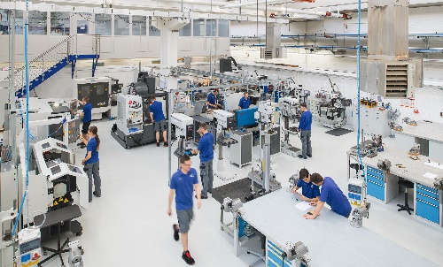  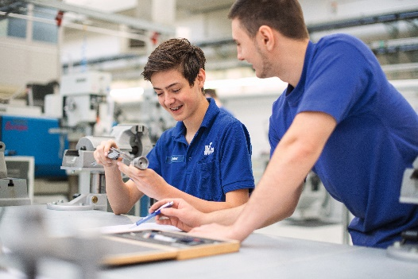  Photo: KIPP | Image file:  KIPP_Azubi-Werkstatt.jpg  Image file:  KIPP_Azubi-Werkstatt_Ausbilder_mit_Azubi.jpg

Image copyright: Released for licence-free and royalty-free publication in speciality media.
Please cite the source and submit a reference.

