Sulz am Neckar, 08 2022

KIPP at the AMB:
Clamping technology for metal machining

At the AMB international exhibition for metal machining, which will take place in Stuttgart from 13th to 17th September, HEINRICH KIPP WERK will be presenting its products and solutions in the field of clamping technology – including the innovative KIPPflexX 5-axis vice in widths of 90 mm or 125 mm and a new multi-clamping system width 50.

The KIPPflexX 5-axis vice can be used as a positive-down force vice or normal vice(2IN1). In addition to this flexibility, the KIPPflexX scores with numerous advantages - including an extremely high clamping force and rigidity, excellent repeat accuracy and large clamping ranges. In line with the great flexibility and multiple benefits, it is not surprising that the target group for the KIPPflexX series is very diverse: The solution is interesting for all companies that use a milling machine - not only in metal machining, but also in tool and mould construction or special engineering.

Another highlight at the AMB is the KIPP multi-clamping system width 50. The new system enables reliable clamping of different workpieces. It is suitable for all batch sizes and allows very high clamping forces. The precision toothing of the system ensures exact repeatability. Last but not least, the conversion from single to multiple clamping is quick and easy.

The KIPP clamping technology programme is divided into four areas: Workholding Technology is covered by a diverse range of components for the universal clamping of workpieces. Clamping elements, positioning elements and clamping accessories for processing machines can be flexibly combined.
The Modular Clamping Technology includes basic elements for mounting workpieces via pre-machined clamping surfaces, grid holes or T-slots. Standardised plates, towers and angles increase flexibility and reduce the number of fixture elements in production to a minimum.
The Zero Point Clamping Technology includes systems for fast, precise clamping and referencing. The 5-axis module clamping system is available for multi-sided machining. Another quick-change system is the positioning and clamping system mechanical/pneumatic.
In Vice Clamping Technology, KIPP offers, among other things, 5-axis clamps for 5-sided machining, NC clamps for 3-axis milling machines, multi-clamping systems for larger quantities and centric clamps with zero point and automation interface.

KIPP can be found at the AMB in exhibition hall 1, booth H82.

(Characters including spaces: 2.414 Zeichen)

Image overview:
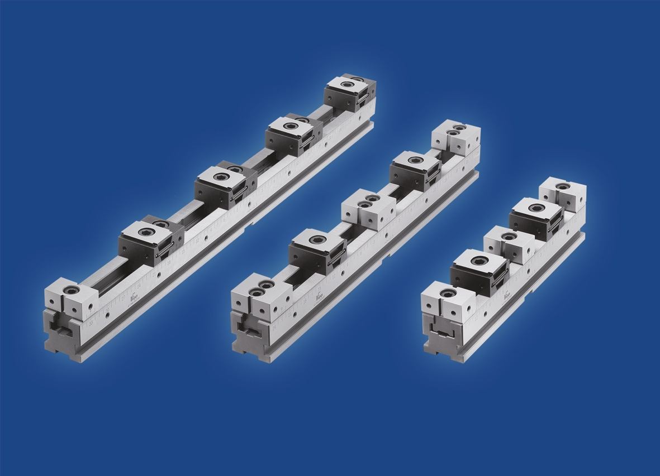
New multi-clamping system width 50 consisting of the variable elements: clamping rails, fixed jaws and wedge clamps (with or without fixed jaw) combined.

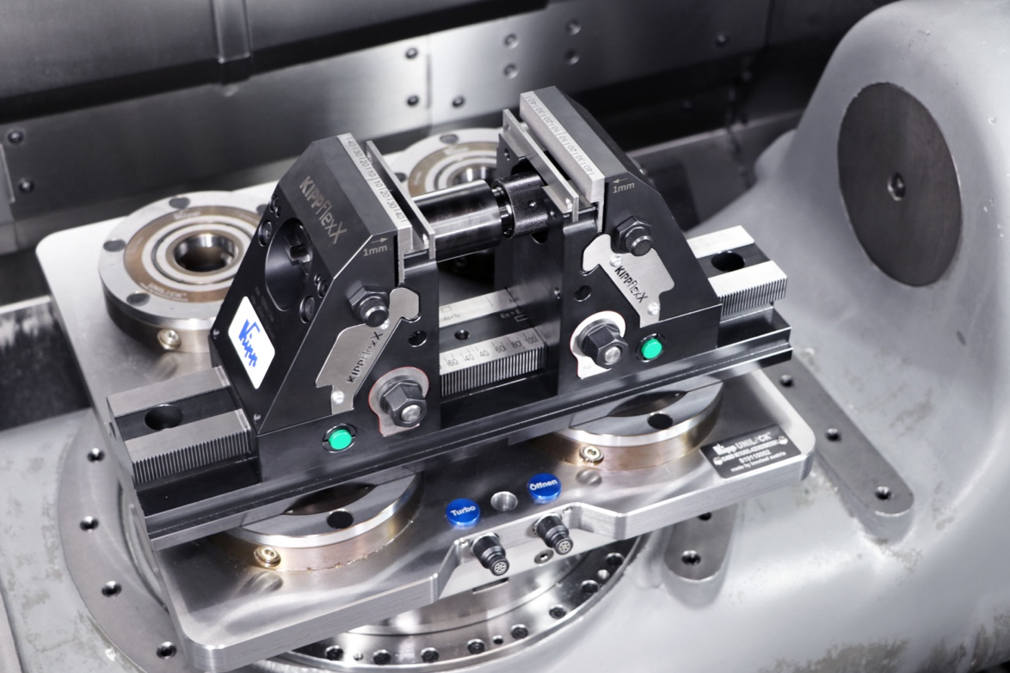
The KIPPflexX 5-axis clamp mounted directly on the UNI lock zero point clamping system.

Deeplinks:
https://www.kippwerk.de/de/de/Produkte/Spanntechnik.html

Weitere Informationen und Pressefotos
Siehe www.kipp.com, Region: Deutschland, Rubrik: News/Pressebereich

Meta-Title: KIPP auf der AMB

Meta-Description: Auf der Fachmesse für Metallbearbeitung präsentiert das HEINRICH KIPP WERK seine Produkte und Lösungen im Bereich der Spanntechnik.

Keywords: KIPP, HEINRICH KIPP WERK, Metallbearbeitung, Spanntechnik, Spannsystem, 5-Achs-Spanner, Niederzugspannung, Rohteilspannung, Nullpunkt-Spannsystem, Schraubstock, Werkstück-Stabilisator, KIPPflexX, 5-Achs-Spanner kompakt, Mehrfach-Spannsystem, Keilspanner, Spannen, Mehrfachspannung, Werkstückanschläge, Festbacken, Spanntechnik

Download-Area:
https://www.kippwerk.de/de/de/Download/Pressebereich.html

HEINRICH KIPP WERK GmbH & Co. KG
Stefanie Beck, Marketing
Heubergstraße 2
72172 Sulz am Neckar

Telefon: 07454 793-30
E-Mail: stefanie.beck@kipp.com

Pressestelle:
Köhler + Partner GmbH
Brauerstraße 42 • 21244 Buchholz i.d.N.
Telefon +49 (0) 4181 92892-0 • Fax +49 (0) 4181 92892-55
info@koehler-partner.de • www.koehler-partner.de

