Press release Sulz am Neckar, Germany, October 2018

Ready for Industry 4.0

KIPP presents the smart product range FEATURE grip

At this years MOTEK the HEINRICH KIPP WERK will be presenting the FEATURE grip product range. The special feature of these products lies in the integrated electromechanical and sensory elements that supply feedback on a specific parameter or status Visitors will be able to inspect this innovative technology from
8 - 11 October at the international exhibition for production and assembly automation in Stuttgart, Germany.

The new functions included in the products in the FEATURE grip range from KIPP offer the user increased benefits. They enable monitoring and can record information such as status or force. Time is saved and process reliability ensured through processing and visualising the information from a central point.

The new KIPP product range includes toggle clamps with force sensors and indexing and ball plungers with status sensors. The sensors in the toggle clamps record the force acting on the workpiece, enabling an exact monitoring of the forces applied. Excesses or shortfalls are communicated on the basis of the preset values.
An app is used to illustrate the status of the indexing plungers: A green light shows when the plunger pin is extended. A red light shows that the plunger pin is retracted and should perhaps be checked. The spring plunger with status sensor indicates if the thrust pin is pushed in or extended. The sensors in the plungers send the signals over a connection cable. In addition, there is also an LED integrated into the plungers which displays the status.

All products in the "FEATURE grip" line enable a link to individual software solutions, systems, mobile devices or apps. The individual values are saved and so can be evaluated at a later date. These products give all customers access to Industry 4.0.

HEINRICH KIPP WERK will be exhibiting in hall 3 at booth 3325. The team looks forward to meeting all interested visitors and invites them to enjoy a Cappuccino or Espresso prepared by a barista in our own CAFÉ lounge.

Characters including spaces:
Headline: 50 characters
Pre-head: 22 characters
Text: 1977 characters
Total: 2049 characters

HEINRICH KIPP WERK KG
Stefanie Beck, Marketing
Heubergstrasse 2
72172 Sulz am Neckar, Germany

Telephone: +49(0)7454 793-30
Email: stefanie.beck@kipp.com

Additional information and press photos
See www.kipp.com, Region: Germany, Category: News / Press area

Photos

KIPP FEATURE grip products with built-in sensors for immediate feedback about parameter or status. Photo: KIPP  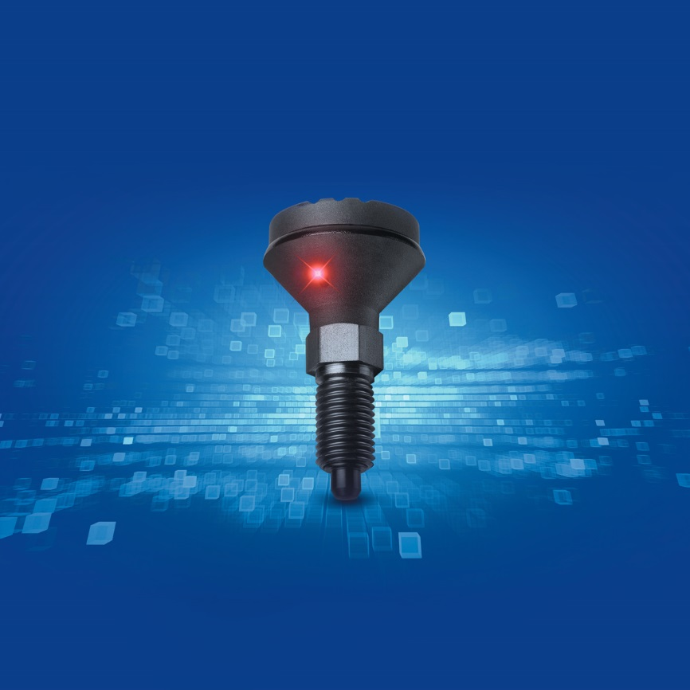 | Image file:  KIPP-FEATURE-grip.jpg

Image copyright: Released for licence-free and royalty-free publication in speciality media.
Please cite the source and submit a reference.

