Press release Sulz am Neckar, Germany, September 2018

Flexible zero-point clamping system in size 138

KIPP 5-axis modular clamping system for XXL workpieces

HEINRICH KIPP WERK has expanded the existing range of 5-axis modular clamping systems to include size 138. This system enables complete five side machining of large and heavy workpieces.

The new 5-axis modular clamping system from KIPP is also suitable for clamping workpieces that exceed 1m in size. The modular design of the system is ideal for efficient and collision-free machining of workpieces with significantly reduced setup times. The easy handling enables quick changeovers with high machine capacity utilization. The workpiece is variably fastened using a thread and precision seating. The product is therefore a fully-fledged, mechanical zero-point clamping system with maximum reproducibility.

The new 138 modular system is compatible and universally applicable with the sizes already available (50 and 80). This XXL version enables fastening with threads up to M60. The maximum support weight for the individual basic module is 10 t. All modules convince through highest clamping forces that positively join the with the system. Thus is absolutely reliable machining guaranteed.

Characters including spaces:
Headline: 54 characters
Pre-head: 47 characters
Text: 1.091 characters
Total: 1.192 characters

HEINRICH KIPP WERK KG
Stefanie Beck, Marketing
Heubergstrasse 2
72172 Sulz am Neckar, Germany

Telephone: +49(0)7454 793-30
Email: stefanie.beck@kipp.com

Additional information and press photos
See www.kipp.com, Region: Germany, Category: News / Press area

Photos

KIPP 5-axis modular clamping system for XXL workpieces Photo: KIPP  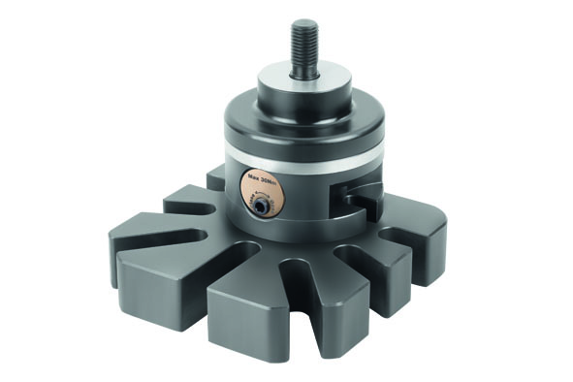 | Image file:  KIPP-5-Achs-Modul-Spannsystem 138.jpg

Image copyright: Released for licence-free and royalty-free publication in speciality media.
Please cite the source and submit a reference.

