Press release Sulz am Neckar, Germany, March 2018

Spring prevents tilting

KIPP optimises the clamp stop for slot profiles

HEINRICH KIPP WERK introduces a market innovation with the clamp stop for slot profiles. The spring loaded screw prevents annoying tilting and eases sliding the stop along the slot. This flexible positioning element with an M6 thread is suitable for various application sectors.

Clamp stops are used to position workpieces in assembly technology, material handling and by plant and fixture construction. A version with internal spring is an innovation and is available from HEINRICH KIPP WERK.The stop is locked by simply turning the star grip. When the stop is loosened, the slot key is pushed down by the spring and the stop can re-positioned without tilting. The spring loaded screw ensures very light sliding and efficient working.

The new clamp stop from KIPP consists of a plastic star grip with female thread, a cylindrical aluminium body and an M6 threaded pin that enables the use of various types of slot key. It is suitable for use with many profile systems e.g. Type B, Type I and DIN 650 T-slots. The KIPP range includes many slot keys available as accessories.

Characters including spaces:
Headline: 47 characters
Pre-head: 23 characters
Text: 1.073 characters
Total: 1.144 characters

HEINRICH KIPP WERK KG
Stefanie Beck, Marketing
Heubergstrasse 2
72172 Sulz am Neckar, Germany

Telephone: +49(0)7454 793-30
Email: stefanie.beck@kipp.com

Additional information and press photos
See www.kipp.com, Region: Germany, Category: News / Press area

Photos

The KIPP clamp stop for slot profiles eases sliding the stop along the slot.  Photo: KIPP  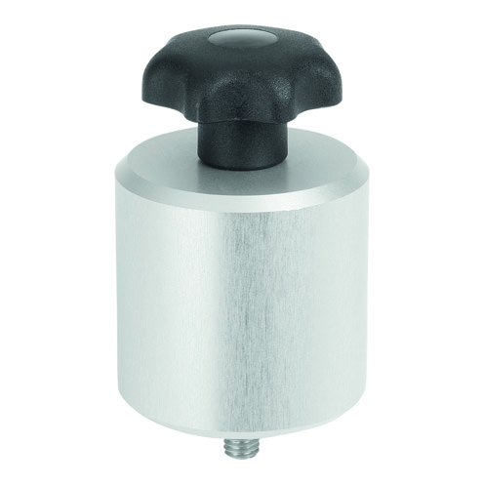 | Image file:  KIPP_Klemmanschlag_Nutprofile_K1214_300dpi.jpg

The KIPP clamp stop for slot profiles positions workpieces. The stop is locked by turning the star grip.  Photo: KIPP  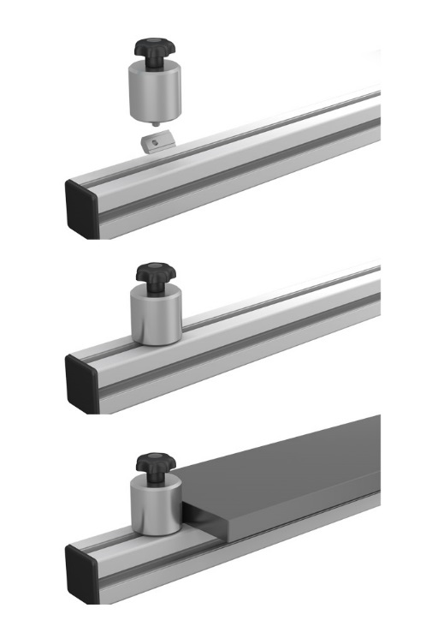 |  |  | Image file:  KIPP_Klemmanschlag_Nutprofile_K1214_Anwendung.jpg

Image copyright: Released for licence-free and royalty-free publication in speciality media.
Please cite the source and submit a reference.

