Press release Sulz am Neckar, Germany, September 2015

New catalogue with innovative clamping systems

KIPP introduces the variable UNI lock zero-point clamping system

In September 2015, HEINRICH KIPP WERK released the new WORKHOLDING SYSTEMS catalogue. This contains over 2000 clamping components, including the UNI lock zero-point clamping system. The innovative system offers impressive features such as simple handling, reliable retaining force and a whole host of clamping options.

The KIPP UNI lock zero-point clamping system facilitates the quick and precise clamping or referencing of fixtures and clamping components. This enables the zero-point clamping system to optimise work on machine-tools, machining centres and measuring equipment. Machine running times are increased through rapid changes, setup times are reduced. Thanks to the defined zero point and highly precise centring via the short taper, this clamping system has a repeat accuracy of up to 0.005 mm.

The new UNI lock zero-point clamping system is yet another addition to KIPP's ever expanding product line of WORKHOLDING SYSTEMS. The clamping pin features a uniform size, which makes it 100% compatible with the entire UNI lock range. The UNI lock system is made of mild steel, guarantees a positive locking and boasts a retaining force of 75,000 N when fastened with M16 screws.

HEINRICH KIPP WERK offers 1x, 2x, 4x or 6x clamping stations with integrated UNI lock installation clamps as standard ex works. Special versions with custom dimensions are also available on request.

Characters including spaces:
Headline: 65 characters
Pre-head: 46 characters
Text: 1,387 characters
Total: 1,498 characters

HEINRICH KIPP WERK KG
Stefanie Beck, Marketing
Heubergstrasse 2
72172 Sulz am Neckar, Germany

Telephone: +49 7454 793-30
E-mail: s.beck@kipp.com

Additional information and press photos
See www.kipp.com, Region: Germany, Category: News/Newsroom

Photos

Image text:
The "UNI lock zero-point clamping system" guarantees quick and precise clamping and referencing of fixtures and workpieces.

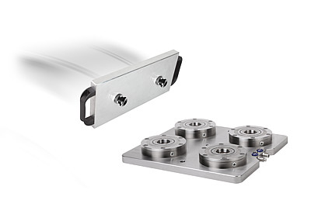  Image copyright: Released for licence and royalty-free publication in speciality media.  Please cite the source and submit a reference. | Image file:  KIPP Nullpunkt Spannsystem UNI lock.jpg

