Press release Sulz am Neckar, Germany, September 2014

For ergonomic handling

New grips for rehab and sports equipment

The HEINRICH KIPP WERK has expanded the "SYMPA touch" series with three quality variants. The characteristic feature of the new operating parts is their special ergonomic grip. KIPP developed the products in close collaboration with experts from the fields of weight training and rehabilitation.

The key features of the new grip designs are a soft surface and ergonomic form. They fit perfectly in the human hand, give gently and guarantee a substantial grip.

During the design stage, KIPP worked very closely with experts from the fields of weight training and rehabilitation. In doing so the activity limitations of fingers or limbs were analysed. The full surface closed grip design prevents the penetration of dirt particles or cleaning agents.

The grip variants are available in three ergonomic forms: as clamping grips with a high round form, as triangular grips and five lobe grips. All SYMPA touch series operating parts have a fibreglass reinforced plastic hard component and a thermoplastic elastomer soft component. They are available with internal thread and external thread in different lengths and the sizes M8 and M10, in steel or stainless steel.

KIPP presents the new development for the first time at the REHACARE in Dusseldorf from 24.09. to 27.09.2014 in Hall 3 / Stand D 37.

Character with space:
Headline: 40 characters
Pre-head: 22 characters
Text: 1.292 characters
Total: 1.354 characters

HEINRICH KIPP WERK KG
Stefanie Beck, Marketing
Heubergstrasse 2
72172 Sulz am Neckar, Germany

Telephone: +49(0)7454 793-30
e-mail: s.beck@kipp.com

Additional information and press photos
See www.kipp.com, Region: Germany, Category: News/Newsroom

Photos

Image text:  The "SYMPA touch" series clamp grips adapt themselves perfectly to gripping movements of the human hand. Photo: KIPP | 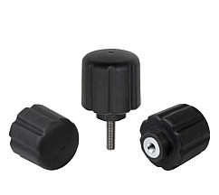  Image file:  KIPP_clamping grip_ergonomic.jpg
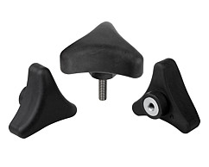
Image file:
KIPP_triangular grip_ergonomic.jpg

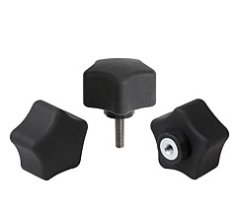
Image file:
KIPP_five lobe grip_ergonomic.jpg

Image copyright: Released for licence and royalty-free publication in speciality media.
With the request to cite the source and receipt.

