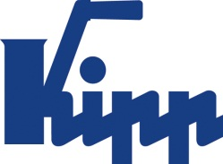

Press release Sulz am Neckar, Germany, April 2014

Clamping levers in new colours

Greater individuality with the 2K COCKATOO

HEINRICH KIPP WERK has expanded its product line featuring the 2K COCKATOO clamping lever. The ergonomically shaped operating unit has a new feel, is extremely durable and is widely used in machine and plant construction. With immediate effect the 2K COCKATOO is available on request in optional colours.

With the introduction of the new 2K COCKATOO colour variations HEINRICH KIPP WERK is laying the foundation for greater individuality in the workplace. The sure-grip operating parts can be colour adapted to the machines and function as a brand effective and custom element. For safe clamping the ergonomic 2K COCKATOO clamping lever colours can act as distinctive warnings.

The efficient 2K COCKATOO clamping lever consists of two component parts. A soft ThermoFlex plastic on the gripping surface produces a soft feel; the hard components cover the mechanical part of the unit. With immediate effect the hard components are available on request from a minimum order quantity of 500 units in red, orange, yellow, green or blue. Thanks to their sophisticated look the colourful variations of the 2K COCKATOO represent a sharp appreciation in the value of KIPP's product line.

Character with space:
Headline: 43 characters
Pre-head: 30 characters
Text: 1,179 characters
Total: 1,252 characters

HEINRICH KIPP WERK KG
Stefanie Beck, Marketing
Heubergstrasse 2
72172 Sulz am Neckar, Germany

Telephone: +49 (0)7454 793-30
e-mail: s.beck@kipp.com

Additional information and press photos
See www.kipp.com, Region: Germany, Category: News/Newsroom

Photo
Clamping levers in new colours  Photo: KIPP | 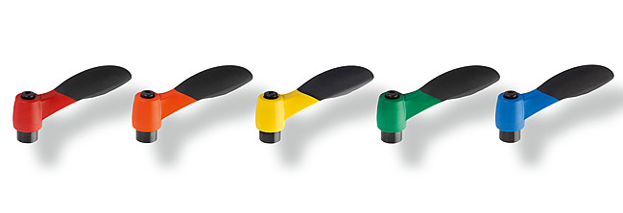  Image file: KIPP_Klemmhebel_2K_KAKADU_Farbvarianten.jpg

