Press release Sulz am Neckar, Germany, December 2018

For large quantities

KIPP introduces pneumatic clamping elements

HEINRICH KIPP WERK has introduced a wide spectrum of new clamping elements into its range. These new products are characterised by a pneumatic operating principle and are suitable for use mainly in machining centres. Partial automation simplifies processes considerably.

The pneumatic machinable collet₁ consists of a pneumatic collet holder made from Q&T steel and a high strength aluminium alloy collet. After the collet holder is screwed onto fixture, the collet is mounted and can be actuated by applying compressed air to the open or close ports. Simple collet changes enable quick and easy clamping of various different workpieces with irregular contours.

The pneumatic pull clamp₂ grips and pulls down a draw bolt screwed into the workpiece. Clamping and releasing is carried out by a compressed air line applied to the specified port. Another compressed air port is used to blow the clamp out and clean the contact face. This port can also be used to ensure that there is no gap between the workpiece and contact face. These pneumatic pull clamps₂ can be used as a zero-point clamping system.

The distinguishing different features of the pneumatic hold-down clamps₃, swing clamps₄ and side clamps₅ manner in which each clamps the workpiece. With the pneumatic hold-down clamps₃ the workpieces are loaded and removed from the side and clamped from above. The pneumatic swing clamp₄ can be pivoted aside to enable the workpiece to be easily mounted or removed from above. The pneumatic side clamp₅ offers optimal accessibility. The workpiece is clamped on the sides leaving the top face free to be machined.

Characters including spaces:
Headline: 43 characters
Pre-head: 20 characters
Text: 1.611 characters
Total: 1.674 characters

HEINRICH KIPP WERK KG
Stefanie Beck, Marketing
Heubergstrasse 2
72172 Sulz am Neckar, Germany

Telephone: +49 7454 793-30
Email: stefanie.beck@kipp.com

Additional information and press photos
See www.kipp.com, Region: Germany, Category: News / Press area

Photos

KIPP introduces pneumatic clamping elements  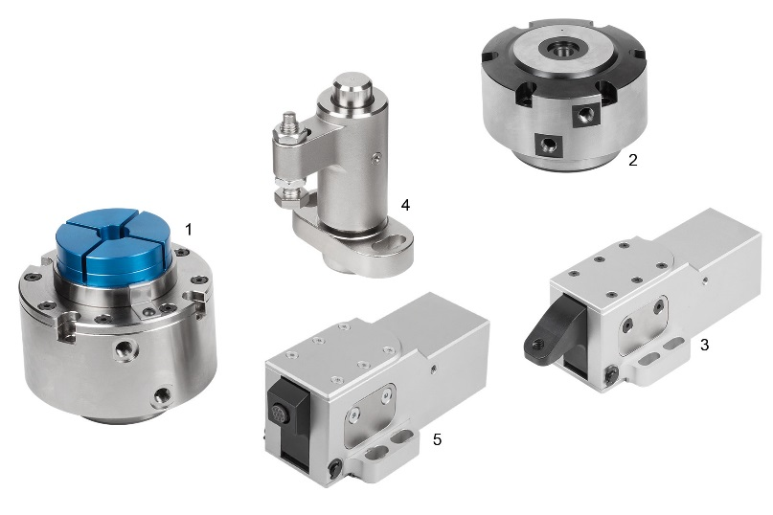 | Image file:  KIPP_Spannelemente_pneumatisch_2018.jpg  K1392 Machinable collets, pneumatic₁  K1390 Pull clamps, pneumatic₂  K1409 Hold-down clamps, pneumatic₃  K1388 Swing clamps, pneumatic₄  K1410 Side clamps, pneumatic₅

Image copyright: Released for licence-free and royalty-free publication in speciality media.
Please cite the source and submit a reference.

