Press release Sulz am Neckar, Germany, April 2016

Lightweight design. Flexible mounting.

KIPP expands its product line of adjustable TUBULAR HANDLES

HEINRICH KIPP WERK is expanding its product line to include aluminium adjustable TUBULAR HANDLES. The advantages of the handle: extreme lightweight due to the aluminium tube, appealing design and flexible mounting options through the freely positionable end pieces.

With the new variable mounting concept, KIPP is introducing a practical handle for plant and machine construction. The mounting brackets and the tubular grip are both aluminium. The materials are anodized, whereas the mounting brackets are available in either black or the typical for aluminium silver-grey.

The grip can be flexibly mounted, as the mounting brackets on the TUBULAR HANDLE can be freely positioned and fastened. The tube is locked in the mounting brackets with cross screws, guaranteeing rotation-free and robust operation.

The tubular handle is mounted from the rear. By longer handles, several mounting brackets can be used. These can be ordered separately as accessories.
The handles are supplied in the lengths L=250 mm to L=600 mm. The end caps of the TUBULAR HANDLE are black polyamide.

Characters including spaces:
Headline: 60 characters
Pre-head: 38 characters
Text: 1073 characters
Total: 1171 characters

HEINRICH KIPP WERK KG
Stefanie Beck, Marketing
Heubergstrasse 2
72172 Sulz am Neckar, Germany

Telephone: +49 7454 793-30
E-mail: stefanie.beck@kipp.com

Additional information and press photos
See www.kipp.com, Region: Germany,
Category: News/Newsroom

Photo
KIPP adjustable TUBULAR HANDLES are freely positionable
Photo: KIPP

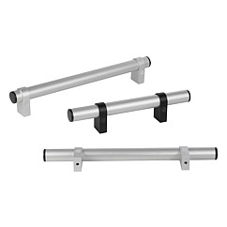 | Image file:  KIPP-ROHRGRIFFE-einstellbar-K1018.jpg

Image copyright: Released for licence and royalty-free publication in speciality media.
Please cite the source and submit a reference.

