Press release Sulz am Neckar, Germany, July 2019

The key to more security - Lockable operating grip from KIPP

Grips and knobs from KIPP are for manual fixating and clamping. They find use in e.g. machine, tool and plant construction as well as on test and medical equipment. The new lockable grips are especially useful for security relevant sectors, where they prevent unauthorised loosening of the fastening or connection.

KIPP has added e.g. lockable five lobe grips suitable for use in equipment construction to the range. These lockable grips also find use in the packaging industry, special machines, toolmaking and for camping equipment. The grips themselves are made from thermoplastic, the steel parts are trivalent blue passivated and the cylinder lock is made from die-cast zinc. This combination of materials guarantee a heat resistance up to 100 °C.

The lockable five lobe grips are available with M8 or M10 female threads- and male threads. KIPP also has an M6 female thread version on offer. All male threads are 20 mm long. Two keys, which can be removed in the open or locked position are supplied with each grip. As the standard version of the lockable five lobe grips are a single-key system, several grips can be locked or opened using just one key, which simplifies daily use. On request, KIPP can produce special versions that have their own individual key or with other threads.

Characters including spaces:
Headline: 60 characters
Text: 1.293 characters
Total: 1.353 characters

HEINRICH KIPP WERK KG
Stefanie Beck, Marketing
Heubergstrasse 2
72172 Sulz am Neckar, Germany

Telephone: +49 7454 793-30
Email: stefanie.beck@kipp.com

Additional information and press photos
See www.kipp.com, Region: Germany, Category: News / Press area

Photos

The key to more security - Lockable operating grip from KIPP  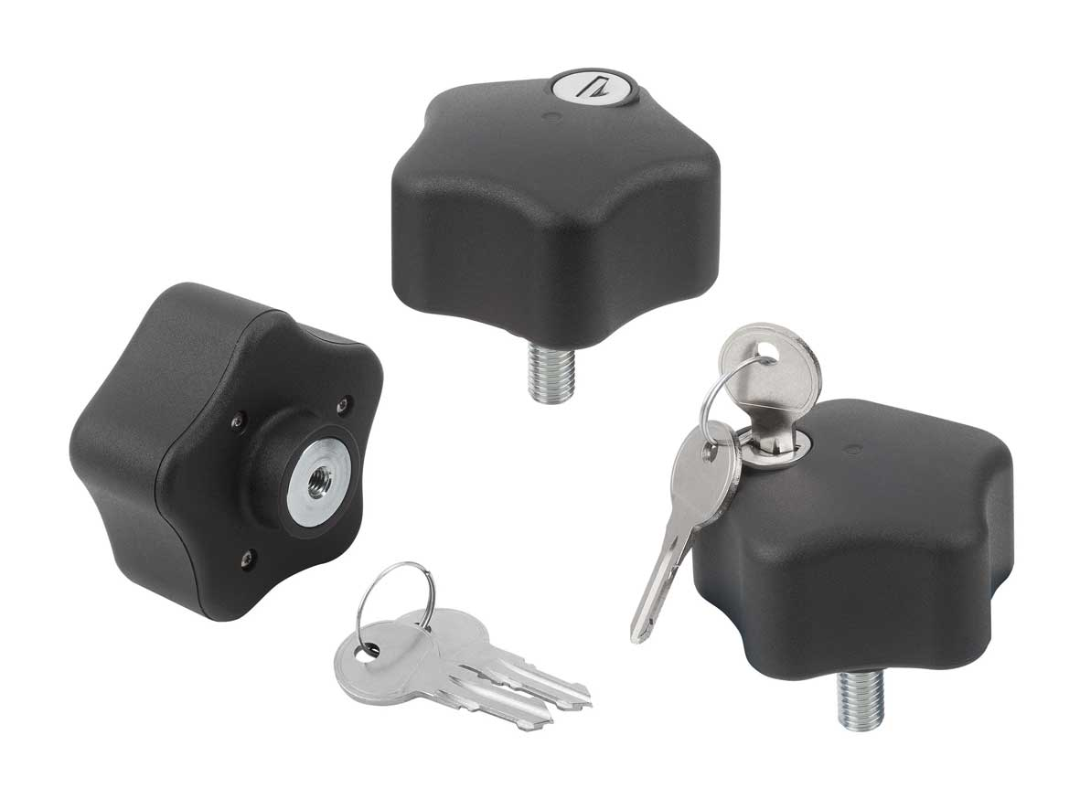 | Image file:  KIPP_Bediengriffe abschließbar_K1378_CMYK.jpg

Image copyright: Released for licence-free and royalty-free publication in speciality media.
Please cite the source and submit a reference.

