Press release Sulz am Neckar, Germany, November 2016

Low-budget design
The ECO is setting new standards when standards when it comes to price-performance ratio

With its ECO clamping lever, HEINRICH KIPP WERK is presenting a functional and design-orientated product as an alternative in the clamping lever sector. The inner workings of the clamping lever have been modified and produced using fibreglass-reinforced plastic.

For over 60 years the KIPP clamping lever has been the symbol for reliability and quality. The product range is now being extended by the ECO clamping lever. And with it, HEINRICH KIPP WERK is presenting a proven product in a totally new, efficient design.

Thanks to its graceful design, the new clamping lever is especially suited to visible applications in industry and trade. However, the product offers a number of improvements in terms of handling. The lever functions by means of a pushing motion rather than a pulling one. This gives the designer the advantage of being able to align the protruding contour to the effective surface.

The many smooth, visible surfaces of the clamping lever and the incredibly soft transitions of the radii give the customer the advantage of a subtle grip design that is simultaneously pleasant to the touch.

KIPP supplies the ECO clamping lever with its ergonomic handle design and proven functionality in three sizes. The products are available with steel external or internal threads.

Characters including spaces:
Headline: 88 characters
Pre- head: 17 characters
Text: 1.290 characters
Total: 1.395 characters

HEINRICH KIPP WERK KG
Stefanie Beck, Marketing
Heubergstrasse 2
72172 Sulz am Neckar, Germany

Telephone: +49 (0) 7454 793-30
e-mail: stefanie.beck@kipp.com

Additional information and press photos
See www.kipp.com, Region: Germany, Category: News / Press area

Photo

Design handle for visible ranges at a fair price. Photo: KIPP  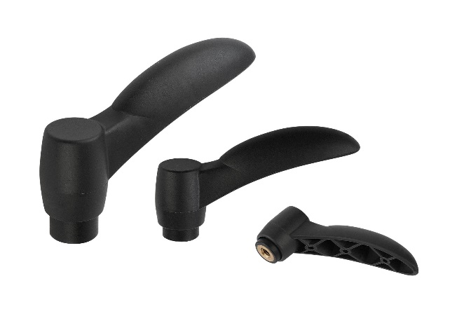 | Image file: KIPP-Klemmhebel-ECO-K0252.jpg
Image copyright: Released for licence-free and royalty-free publication in speciality media.
Please cite the source and submit a reference.

