Press release Sulz am Neckar, Germany, August 2016

KIPP at the AMB - Hall 1 | Stand 1I71

Clamping, machining, manufacturing – complete solutions from KIPP

The HEINRICH KIPP WERK released the new WORKHOLDING SYSTEMS catalogue at the end of 2015. The catalogue contains more than 2000 clamping components, including the UNI lock zero-point clamping system, the UNI lock 5-axis modular system
and the 5-axis clamping system compact.

The UNI lock zero-point clamping system from KIPP facilitates the quick and precise clamping of fixtures and clamping components. This optimises work on machine-tools, machining centres and measuring equipment:

- Workpieces or fixtures can be exchanged in seconds
- Significant reduction of set-up times
- Positive locking and retaining force up to 75,000 N
- 100% compatibility with 5-axis modular system

The compatible KIPP UNI lock 5-axis modular system was developed specifically for 5-side machining. Also ideal for clamping complex workpieces. They can be completely machined in a single clamping setup and are positively coupled with the 5-axis modular system.
The modular construction and the wide variety of modules allows the system to be individually configured and recombined for all applications. More than 70 elements are available. An innovative expansion of the range in the form of a smaller modular system will be presented at the AMB.

With its "5-axis clamping system compact", KIPP is setting new standards for 5-side machining of complex workpieces on modern 5-axis machines. Key features:
new clamping technology with integrated positive down function along with flexibility for small and large workpieces.

Advantages:
- Positive down effect on both jaw plates
- Very high tractive force and rigidity in the system
- Clamping width up to 320 mm, freely extendable
- Excellent tool accessibility which in turn increases tool service life

KIPP will be presenting products with a proven track record at the AMB in Stuttgart, showing how they can be combined to create perfect all-round solutions.

Characters including spaces:
Headline: 65 characters
Pre-head: 37 characters
Text: 1879 characters
Total: 1981 characters

HEINRICH KIPP WERK KG
Stefanie Beck, Marketing
Heubergstrasse 2
72172 Sulz am Neckar, Germany

Telephone: +49 (0) 7454 793-30
e-mail: stefanie.beck@kipp.com

Additional information and press photos
See www.kipp.com, Region: Germany, Category: News/Newsroom

Photo
Workholding systems from KIPP
Photo: KIPP

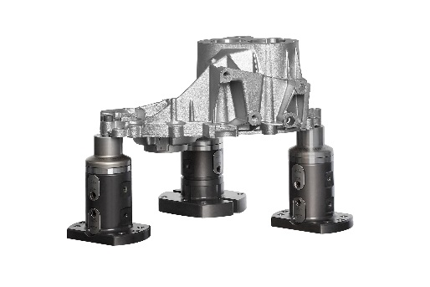  Image file  KIPP-5-Achs-Modulsystem-UNI lock.jpg  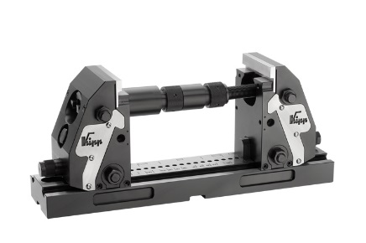  Image file:  KIPP-5-Achs-Spanner kompakt.jpg | 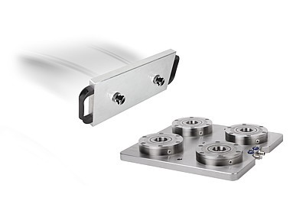  Image file:  KIPP-Nullpunkt-Spannsystem-UNI lock.jpg

Image copyright: Released for licence-free and royalty-free publication in speciality media.
Please cite the source and submit a reference.

