Press release Sulz am Neckar, Germany, May 2014

Fulfill their expectations

KIPP Clamping rings in two versions

HEINRICH KIPP WERK presents a special innovation at the Automatica 2014. The product group machine and fixture elements will be expanded with slotted and split clamping rings. The clamping rings fixate stop elements on shafts accurately and reliably without damaging them.

The KIPP clamping rings can accommodate light transverse forces and thereby prevent, e.g. the shaft from wandering out of the guide. Due to the high retention forces the elements can also be reliably clamped in the middle of shafts. Due to even distribution of the clamping forces and the complete enclosure of the shaft, damages are precluded.

Both the slotted and the split KIPP clamp rings are clamped by screws in the rings onto the shaft. The use of the split ring shaft clamping has the advantage that it can be positioned at any location on the shaft when the shaft has already been permanently mounted. The two-piece design allows for easy and fast installation without dismantling the adjacent components. For reliable clamping, the shaft tolerance should be within h11.

The HEINRICH KIPP WERK supplies the clamping rings that can be used in a temperature range of - 40°C to +175°C without problem, in steel and stainless steel. Other dimensions for shafts are also available on request.

Character with space:
Headline: 36 characters
Pre-head: 26 characters
Text: 1,266 characters
Total: 1,328 characters

HEINRICH KIPP WERK KG
Stefanie Beck, Marketing
Heubergstraße 2
72172 Sulz am Neckar, Germany

Telephone: +49(0)7454 793-30
e-mail: s.beck@kipp.com

Additional information and press photos
See www.kipp.com, Region: Germany, Category: News/Newsroom

Photos

Image text:  KIPP clamping ring halves enclose the shaft with a uniformly distributed clamping force.  Photo: KIPP | 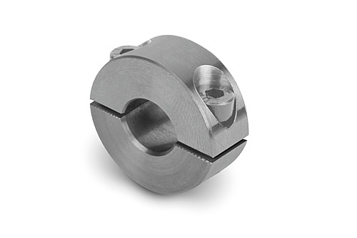  Image file:  KIPP_Clamping_ring_split.jpg

Image text:  KIPP slotted clamping rings surround the shaft with a uniformly distributed clamping force.  Photo: KIPP  Image copyright: Released for licence and royalty-free publication in speciality media. With the request to cite the source and receipt. | Image file:  KIPP_Clamping_ring_split.jpg

