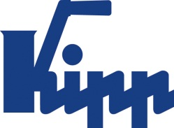

Press release Sulz am Neckar, Germany, July 2017

New appearance, tried and tested function

KIPP stainless steel products: Now in Matt-Look

Clamping levers, cam levers, pull handles: Many of the proven KIPP operating parts are now available in an attractive stainless steel design. The sand blasted products with a matt finish are a practical and attractive product expansion - they are rust-free, resistant and unobtrusive.

Due to hygienic requirements the use of stainless steel products in the food stuff or chemical sectors is an absolute must. The high life expectancy and the possiblity of hygienic cleaning make them suitable for use on plants and machines in sensitive areas or for use outside. Stainless steel products also often find use in vehicle construction and by storage and operating facilities.
The main benefits are the advantages of the material: Compared to polished versions, operating parts with matt finishes are unobtrusive. The material is also non-reflective, which is a huge advantage when used on equipment that have optical sensors.
HEINRICH KIPP WERK now offers all practical star and palm grips with male threads. The threaded pins are joined to the main body with a transverse pin. This enables the use of higher torques. The new KIPP stainless steel products are available now ex-stock.

Characters including spaces:
Headline: 47 characters
Pre-head: 41 characters
Text: 1.181 characters
Total: 1.269 characters

HEINRICH KIPP WERK KG
Stefanie Beck, Marketing
Heubergstrasse 2
72172 Sulz am Neckar, Germany

Telephone: +49(0)7454 793-30
Email: stefanie.beck@kipp.com

Additional information and press photos
See www.kipp.com, Region: Germany, Category: News / Press area

Photo

KIPP stainless steel products in modern Matt-Look  Photo: KIPP  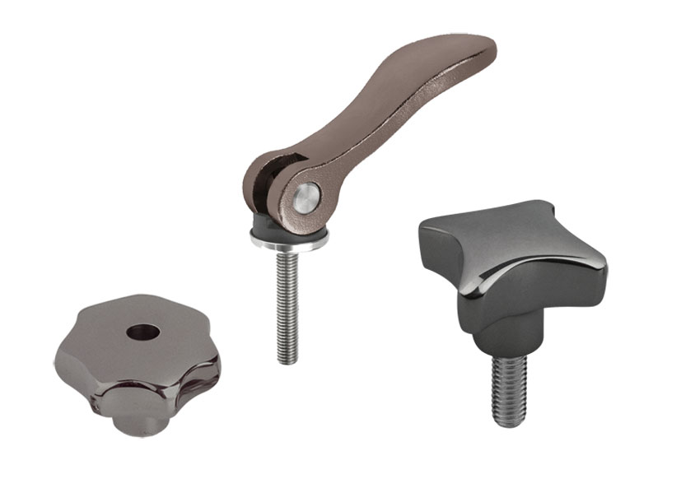 | Image file:  KIPP-Stainless steel products.jpg
Image copyright: Released for licence-free and royalty-free publication in speciality media.
Please cite the source and submit a reference.

