Press release Sulz am Neckar, Germany, April 2017

To disengage!

KIPP presents user friendly clamping levers with push button

The HEINRICH KIPP WERK has introduced a new version of the reliable clamping lever into the existing product range. This has a practical push button which eases the releasing and safe implementation of the lever.

A disengagement push button allows the new KIPP clamping lever to be released and re-positioned in seconds. The comfortable operation makes the clamping lever a good alternative by often used clamping and adjustment applications in machine and plant construction. The release of the lever by push button is intuitive as the operating function can be immediately seen.

The colour combination – black grip with coloured thrust pad, or visa-versa - upgrades the appearance by visual applications. As standard, the clamping levers are available with female- or male threads. The grip is made from fibreglass reinforced plastic, the threads from steel or stainless steel. The clamping levers with push button are available ex works with the lengths 20 to 60 mm and thread sizes M5 to M10 and also in a wide variety of other sizes and versions.

Characters including spaces:
Headline: 60 characters
Pre-head: 13 characters
Text: 1.049 characters
Total: 1.122 characters

HEINRICH KIPP WERK KG
Stefanie Beck, Marketing
Heubergstrasse 2
72172 Sulz am Neckar, Germany

Telephone: +49 7454 793-30
Email: stefanie.beck@kipp.com

Additional information and press photos
See www.kipp.com, Region: Germany, Category: News / Press area

Photo

Clamping lever with push button. Photo: KIPP  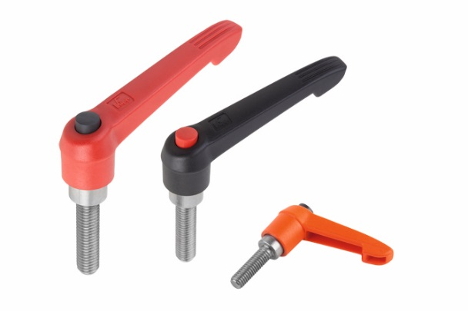 | Image file: KIPP-Clamping Lever with push button-K 0270.jpg
Image copyright: Released for licence-free and royalty-free publication in speciality media.
Please cite the source and submit a reference.

