Press release Sulz am Neckar, Germany, April 2017

Quick connections

New KIPP ball lock pins with a simple principle

The HEINRICH KIPP WERK has added new ball lock pins to its range. Two parts or workpieces can be simply joined or fixated by just a press of a button. Also new, special stainless steel versions suitable for demanding applications.

The ball lock pins from KIPP are functional components that operate on a simple and well known principle. When a button in the head of the pin is pressed, the balls in the other end of the pin are unlocked and retracted into the pin body. The ball lock pin can now be pushed through the pre-drilled holes in the parts being joined. When the button is now released, the balls move back out under spring force and are locked. The pin cannot work loose through vibration or some other means.

KIPP offers the ball lock pins ex works with T, L or mushroom grip made from black thermoplastic and the steel parts made from stainless steel, with pin diameters 5-16 mm and lengths 10-80 mm. They have a small hole in the head where, if required a tether cable can be attached. High strength, hardened stainless steel pins that can withstand high loads are also included in the range. These find use in the foodstuff and chemical industries or in the aerospace industries. These ball lock pins from KIPP have a practical ring grip to which a tether cable can also be fastened.

Characters including spaces:
Headline: 47 characters
Pre-head: 17 characters
Text: 1.296 characters
Total: 1.360 characters

HEINRICH KIPP WERK KG
Stefanie Beck, Marketing
Heubergstrasse 2
72172 Sulz am Neckar, Germany

Telephone: +49(0)7454 793-30
Email: stefanie.beck@kipp.com

Additional information and press photos
See www.kipp.com, Region: Germany, Category: News / Press area

Photo

Ball lock pin with ring grip. Photo: KIPP  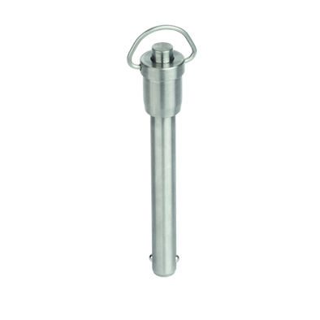 | Image file: KIPP-Kugelsperrbolzen-mit-Ringgriff-Edelstahl-selbstsichernd-K0746.jpg

Image copyright: Released for licence-free and royalty-free publication in speciality media.
Please cite the source and submit a reference.

